Thanks bro, it looks good, I still need to figure out how to put it in test mode and add orders to test it etc
- Change first opening slide to: Established 2015 (not 2020)

- For the SNAPS page, how do I alter the images to include the original customer catch snaps?

- Rather than “Built for the elements”., down the bottom of page I’d like to hang ether catch phrase to “Never Out of a Catch”

- On the Home page: Change “"Finally, a premium brand that actually understands NZ conditions. The lures are practically indestructible and the colors are perfectly matched to our baitfish."

Mike Thompson
Weekend Warrior

To “What impressed me most is how well it holds up over time. No fraying, no colour bleed like I’ve had with other brands, it’s super sensitive, you can feel every little nibble.
Mike Thompson
Weekend Warrior

- On the Home page: Make this the first one on the most left of the page, and change “"We've been using Catch-22 braid on our commercial rigs for two seasons now. It's the only line that stands up to the abrasion of the Three Kings coast."”

Capt. Finn
Thunder Charters

To “ There you go mate! 40.1kg Kingfish, we got 4 yesterday. Your braid doing the business!”
Capt. Charles
Thunder Charter

- On the Home page: Make this the second testimonial and Change "The feedback through the rod with this braid is incredible. I can feel every micro-touch, even in deep water. A complete game changer for my setup."

Sarah Jenkins
Tournament Angler

To: “She’s like rope, it’s bloody good stuff. Bay of Plenty Boat Hire use this stuff on their rods when they’re catching the big stuff – This is the braid we use on all our gear.”

Ham & Cheese
Local NZ Fishing Celebrities

- How do I change the pictures for the groups on our partners? – as well as fix the links

- On the shipping and return page, underneath “Damaged Goods
Catch-22 is not responsible for loss or damage to goods caused by transit events once dispatched. We recommend inspecting your package upon arrival before signing“

Please remove “We recommend inspecting your package upon arrival before signing” and instead replace it with “If you receive a damaged item, please contact us so we can lodge this with NZ Post”

- On the Home page: put the “Store Selection Best Sellers” section widget below the “Proven Performance Trusted By The Pros” widget section

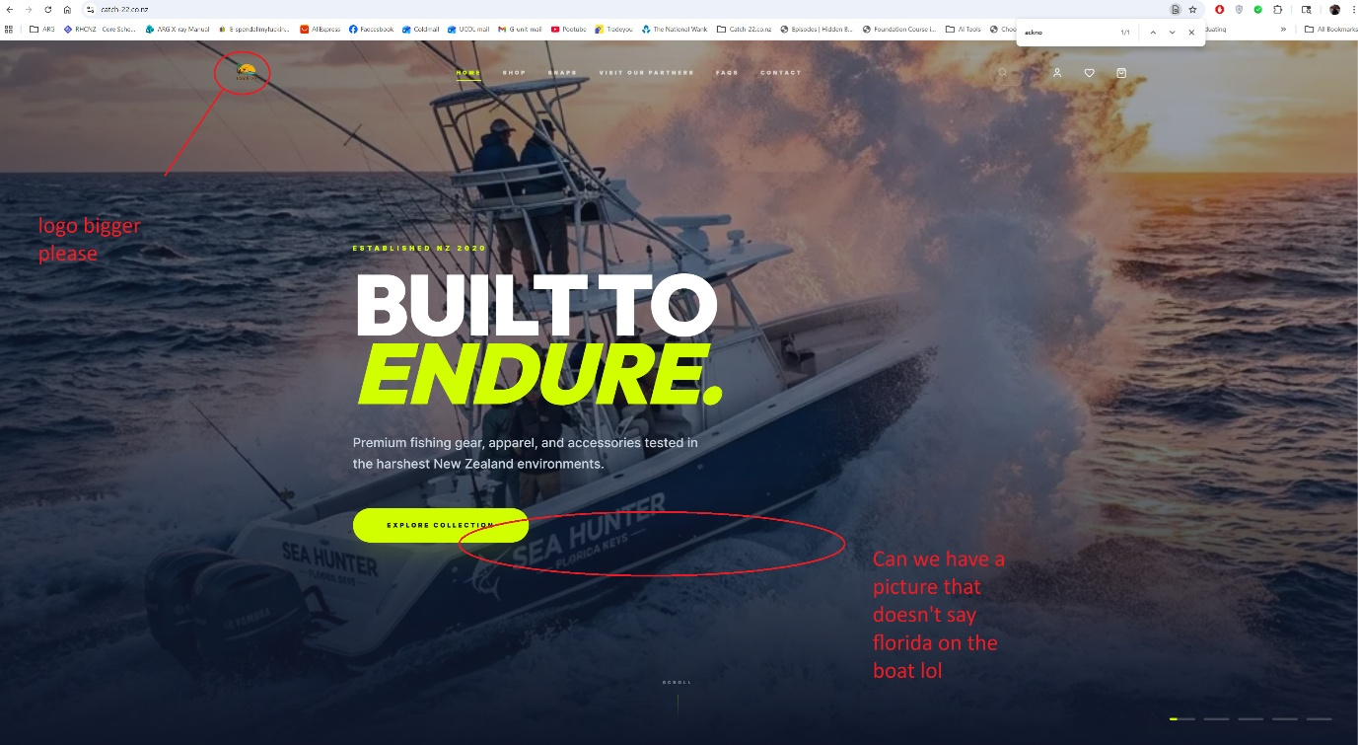

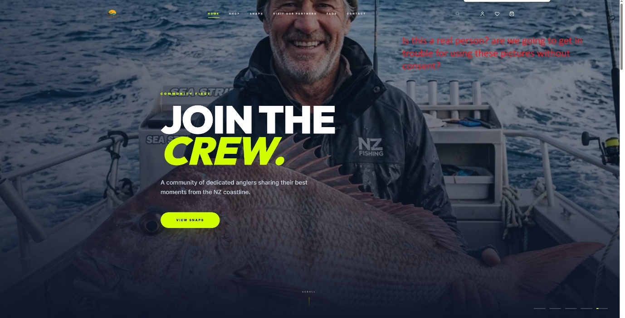
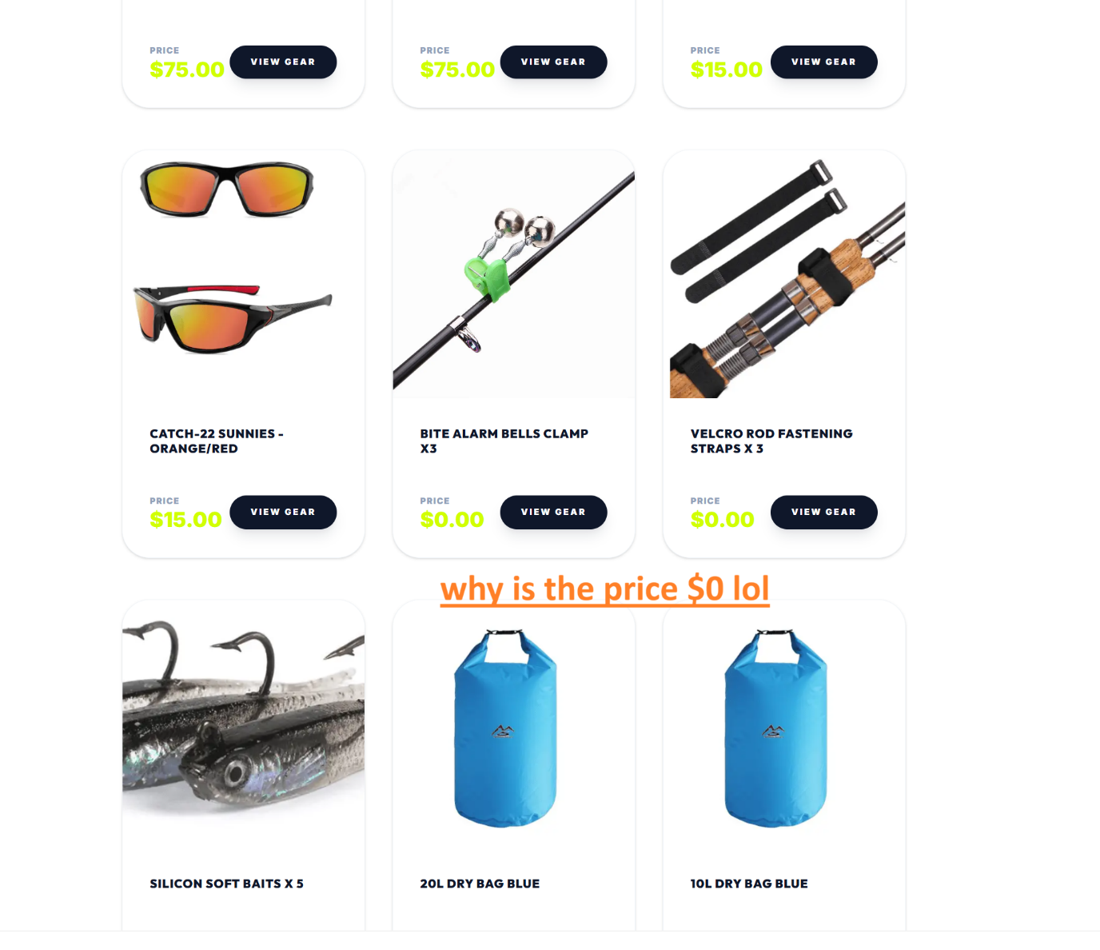
Do we still have access to the original prices?

